Lab 1: Setting up the Web Development Environment
- Objectives:
- Configure a developer environment (VS Code, browsers, Git) and understand the basic web stack. - Tools/Tech:
- VS Code, Chrome/Firefox, Git/GitHub, Node.js (optional)
- Tasks/Steps:
1. Install VS Code and essential extensions (Live Server, Prettier).
2. Install Git and create a GitHub account/repository for the course.
3. Clone a starter repo and run Live Server.
4. Create a README with project structure and commit changes.
- Deliverables:
- GitHub repo with initial commit, README, and a simple index.html served via Live Server. - Environment installed and verified (4), correct Git workflow & commit history (4), README quality (2). Solution:
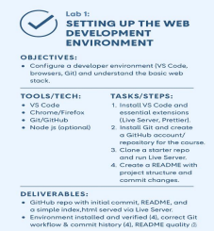
Complete Installation Steps for Web Development Setup 1. Install a Code Editor
• Download and install Visual Studio Code
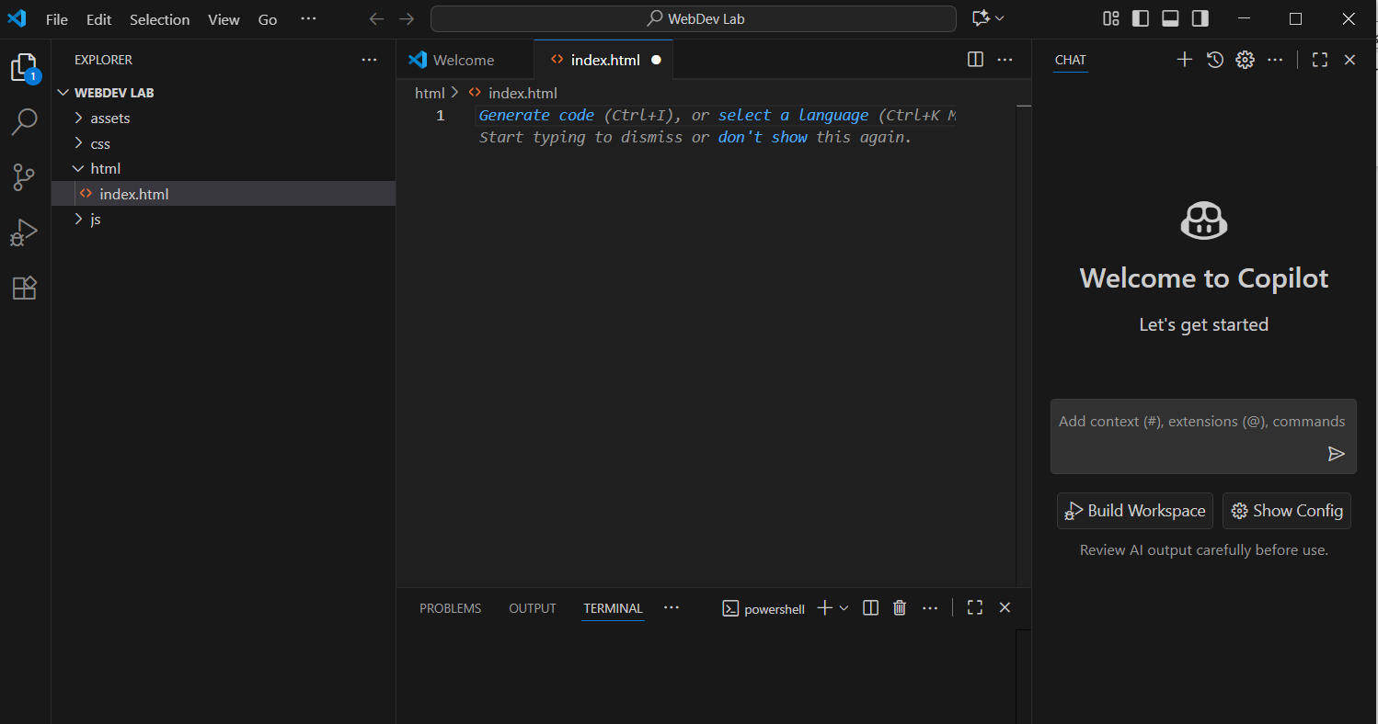

• Optional: Install extensions like Live Server, Prettier, and ESLint
Live Server: ESLint:
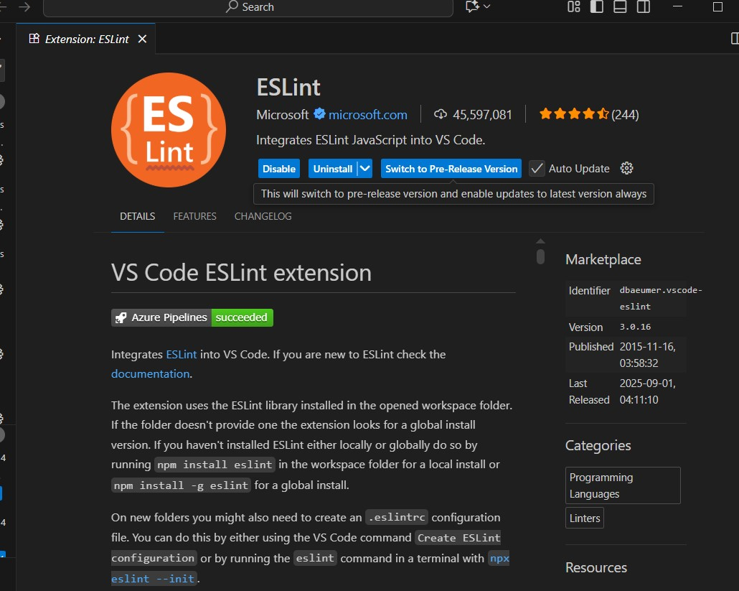
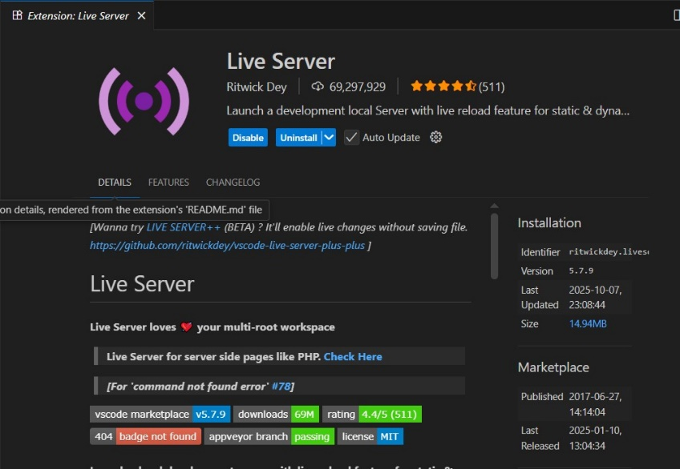

Prettier:

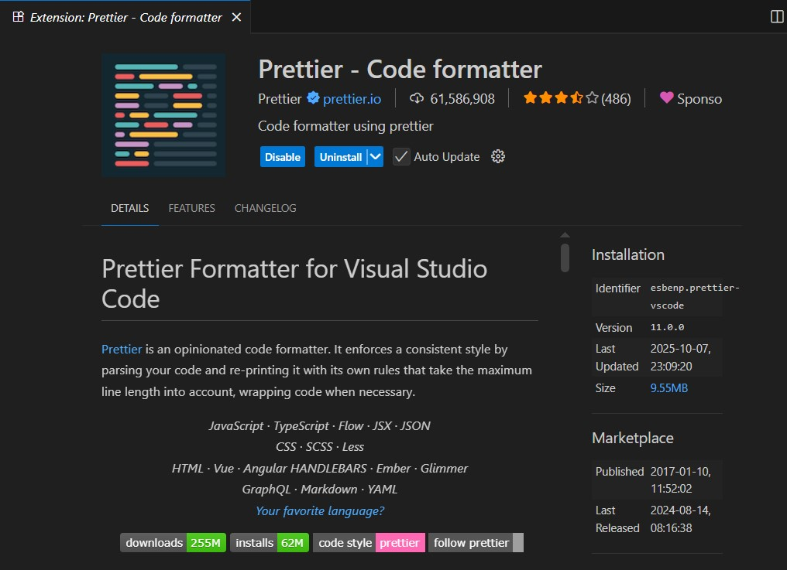

2. Install Web Browsers
• Ensure you have the latest versions of Google Chrome and Mozilla Firefox for testing
Chrome:
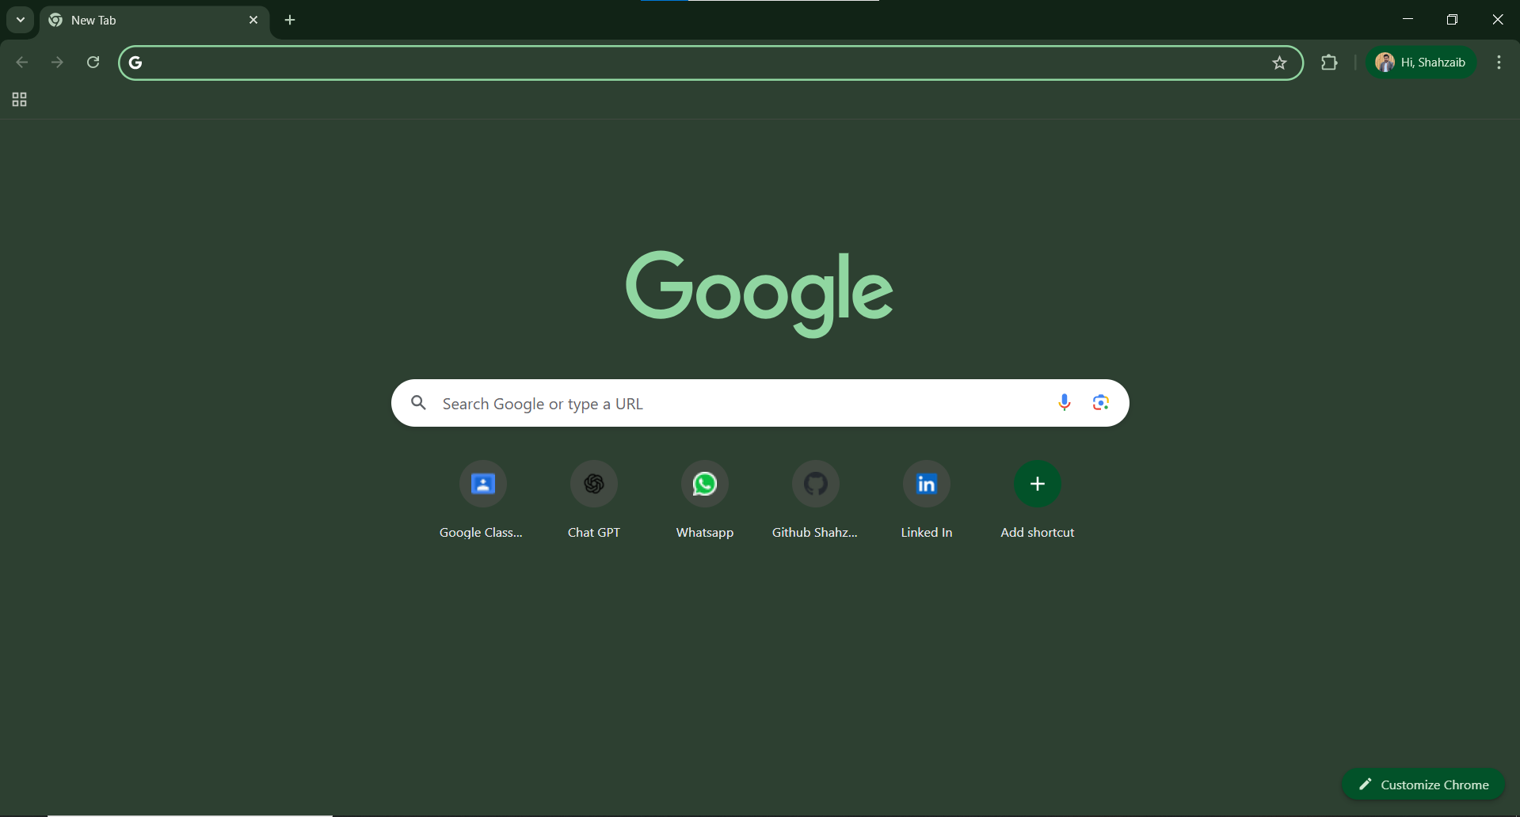

3. Set Up Version Control
• Install Git
• Configure Git with your username and email:
• git config --global user.name "Your Name"
• git config --global user.email "you@example.com"
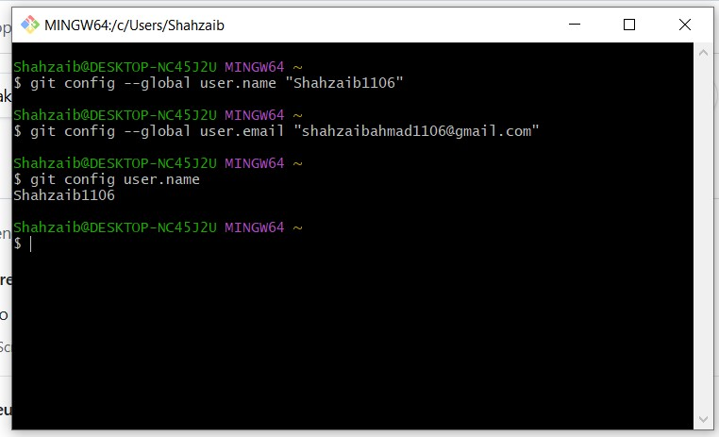

4. Create a Project Folder
• Make a folder named WebDevLab1 on your desktop or preferred location • Inside, create subfolders: html, css, js, and assets
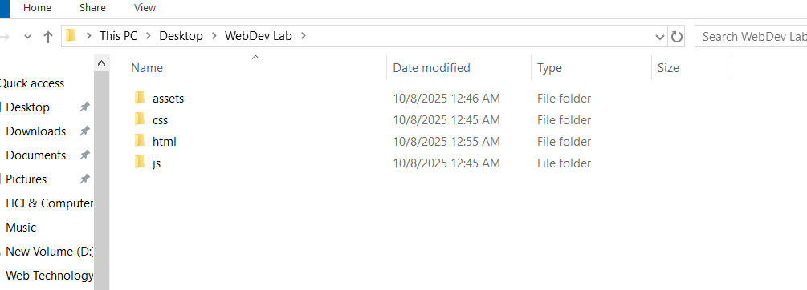

5. Initialize Git Repository
• Open the folder in VS Code
• Run:
• git init

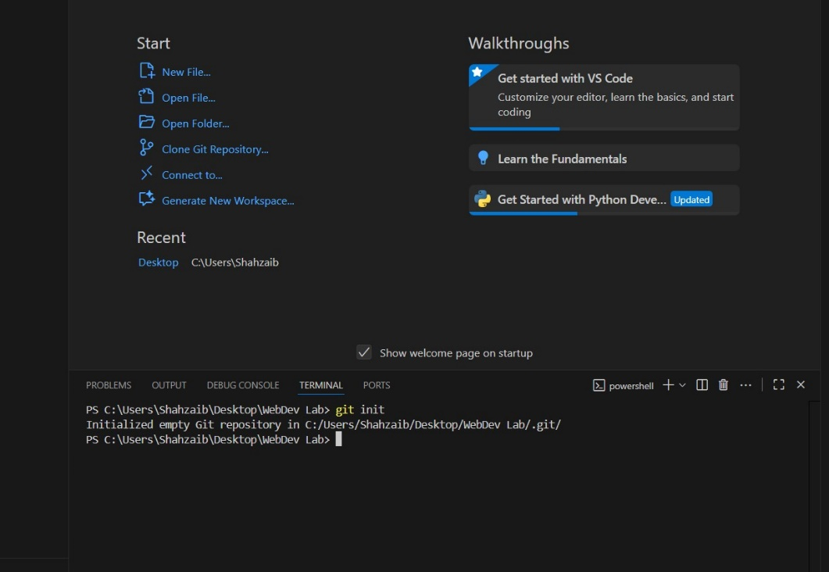
6. Install Live Server
• In VS Code, go to Extensions → Search for “Live Server” → Click Install • Right-click your index.html file → “Open with Live Server”
7. Verify Setup
• Open index.html and add:
• <!DOCTYPE html>
• <html>
• <head><title>Lab 1</title></head>
• <body><h1>Web Development Setup Complete!</h1></body>
• </html>
• Launch with Live Server to confirm everything works
Code:

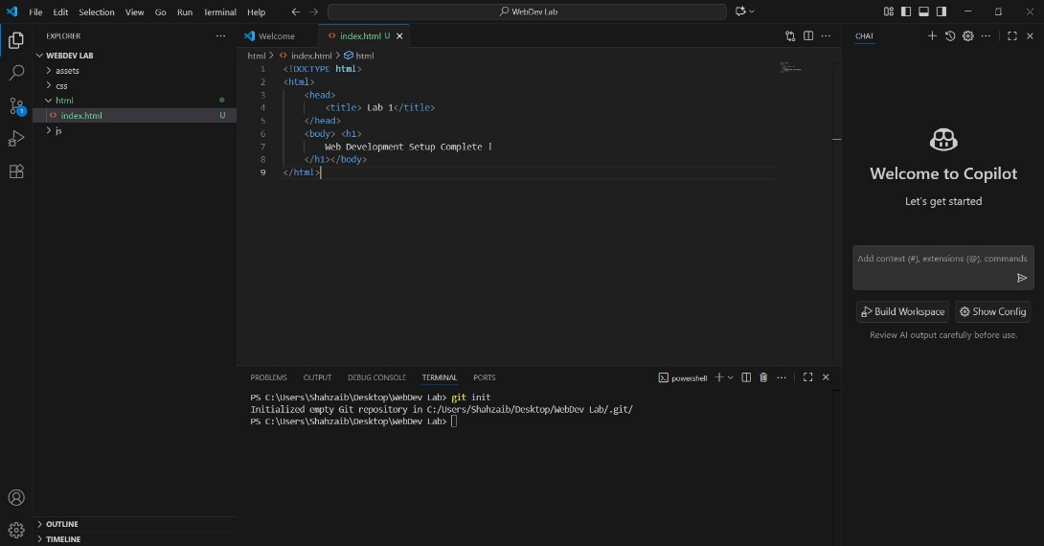

Web Setup :

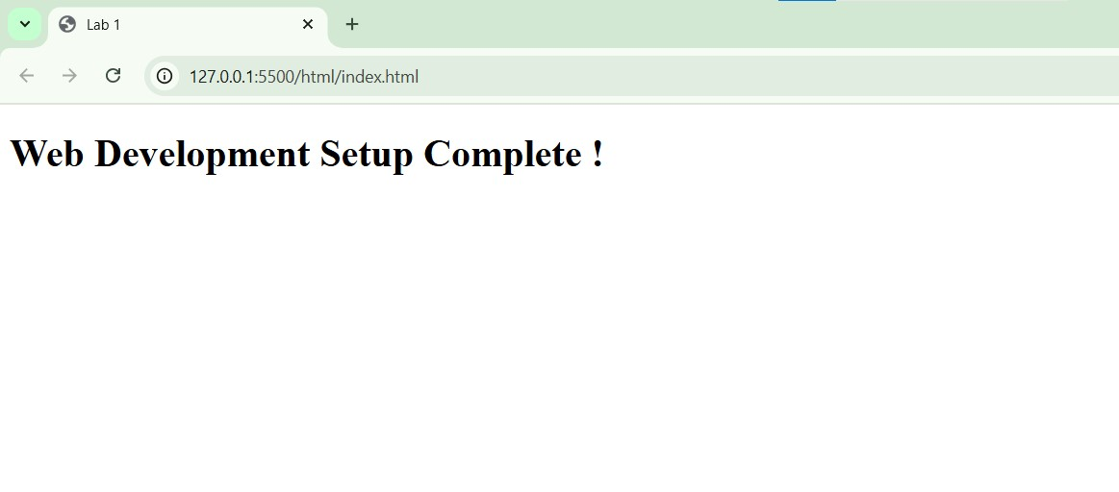
CONCLUSION:
____I have downloaded the web development setup, git and extensions and successfully upload my file on GitHub.
RUBRICS:

Performance |  |  | Lab Report
Description | Total  Marks | Marks  Obtained | Description | Total  Marks | Marks  Obtained
Ability to  Conduct  practical | 5 |  | Structure | 5
Data Analysis &  Interpretation | 5 |  | Efficiency | 5
Total Marks obtained |  |  | Total Marks Obtained

Instructor Signature

